Duane McDaniels
July 27, 1940 – January 20, 2026

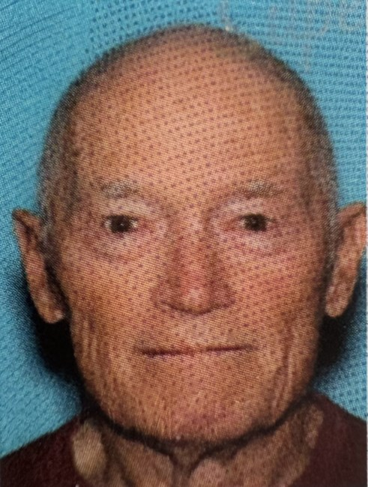
Duane Joseph McDaniels, 85, of Commerce Township passed away peacefully on January 20, 2026. He was the beloved husband of the late Judy McDaniels, whose memory he cherished until his last days following her passing on September 12, 2022. Duane and Judy shared a passion for skiing, boating and bicycling, which took them on many memorable trips throughout the United States and Europe.
Duane retired from IBM, where he served as a technical repair technician. Beyond his professional life, Duane was an avid Motorcycle road racer known throughout the United States and Canada. In 2009 Duane was inducted into the Canadian Motorcycle Hall of Fame He embraced the outdoors with enthusiasm & joy.
Duane will be dearly missed by his devoted nieces Kathleen Crawford and Shelly Smith, his brother-in-law William (Karen) Smith, and many other dear nieces and nephews. He will also be missed by his close friends, Art, Vince, Al, Kathy and Suzee.
Those who knew him will remember his intelligent conversations, marked by the pursuit of excitement and readiness for adventure. Duane had a well lived life, defined by love, friendship, and the thrill of the ride.
Memorial contributions in Duane's loving memory may be made to The Michigan Humane Society,

